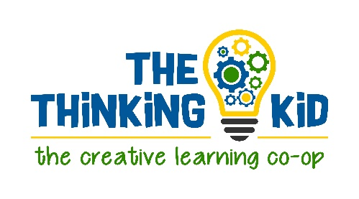
Frequently Asked Questions

Q: What is an affiliate program?
A: An affiliate program is a marketing program that allows a person (an affiliate) to receive a commission for generating sales for a company.

Q: How does your affiliate program work?
A: As an affiliate, you place specially generated links in your blog posts, social media posts, emails, etc. These links drive traffic to our website. When a reader clicks your link and makes a purchase on our site, we pay you a commission for that sale. We provide you with banners, text links, and other marketing materials that you can use to promote our products on your site.

Q: What is the commission rate and how will I be paid?
A: The Thinking Kid offers a $5 commission on all purchases made through your unique affiliate link. Affiliates are paid monthly via Paypal (put a link to Paypal here) when the commission balance reaches a threshold of $25. If an affiliate decides to leave the TTK affiliate program and has less than $25 in outstanding approved commissions, the commissions will be forfeited. Upon request, the outstanding commission amount will be applied as TTK credit.

Q: How will you track customers that come through my ad?
A: We will give you a unique coupon code that gives your client/follower a discount for their purchase at TTK. We will track through the coupon code.

Q: Who can become a TTK affiliate?
A: We are looking for people who have experienced our TTK clubs. We offer $1 trial sessions, which will give you a great feel for our teaching style and enthusiasm approach. If you have not taken one of our online clubs, you have no idea how fun interactive online learning can be! We want you to truly vouch for the excellence we offer with our TTK clubs.
We are looking for affiliates who demonstrate our values of education by helping parents find wholesome and high-quality learning aids. Your reach within the homeschooling and after-schooling community may come through a blog, website, social media platform, email, support group, and more.
We are not looking for an affiliate with a large number of random ads and affiliate links without context.
All affiliate applications will be reviewed with these key factors in mind.

Q: How can I become a TTK affiliate?
A: It’s simple! Just complete this form.
If this link does not work, please copy paste this into your browser: https://forms.gle/tqSRumxvBzyNw3pY8.

Q: Can I use my affiliate link to earn a commission on my own purchases?
A: No, you may not earn commissions on personal purchases. Please see our TTK Terms and Conditions for more information.

